**CI251 Homework 2**

**Due 1/30/2020 (Tuesday 4:00pm)**

**Send your Github link to jzhang@eastwest.edu**

Program 1

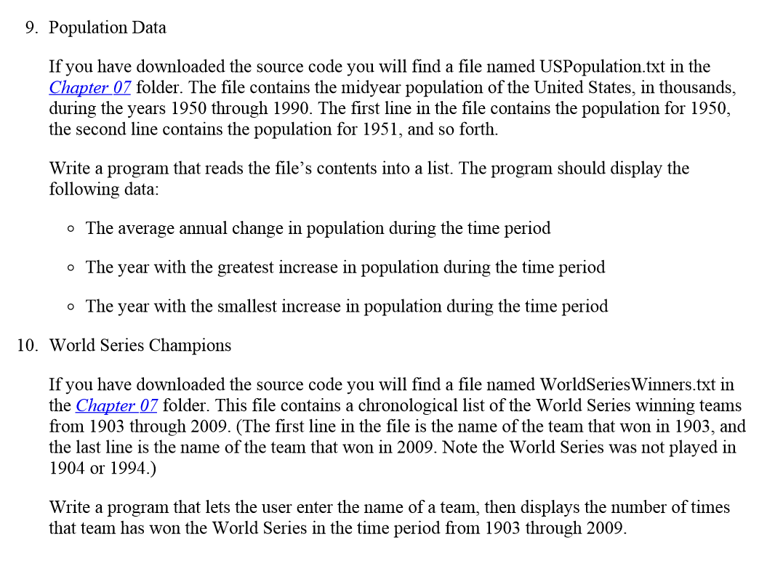

Program 2

In the student sample programs for this book, you will find a text file named 1994_Weekly_Gas_Averages.txt. The file contains the average gas price for each week in the year 1994. (There are 52 lines in the file.) Using matplotlib, write a Python program that reads the contents of the file then plots the data as either a line graph or a bar chart. Be sure to display meaningful labels along the X and Y axes, as well as the tick marks.

Bonus ( 5 pts)

